Equipment list
NAME:_________________________________________
Common lab equipment
EQUIPMENT  NAME | 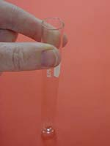 | SCIENTIFIC DRAWING | A small, thin, glass container for mixing small amounts of chemicals. A boiling tube is a larger test tube that is designed for heating liquids.
 | 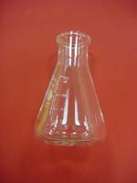 |  | A heat-proof glass container that is used instead of a beaker because it can be swirled better, and can also slow down loss by evaporation. Filter funnels sit well on top of these also.
 | 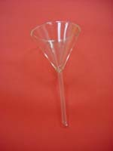 |  | Used to pour liquids safely into small-mouthed containers, and to support filter paper when filtering a solution.
 | 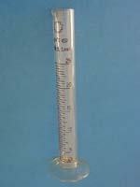 |  | A tall, thin container used to measure amounts of liquid accurately.
 | 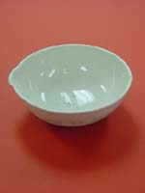 |  | A heat-proof container designed to allow liquid to evaporate away more quickly, usually to leave behind a solid.
 | 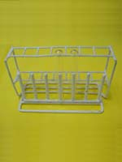 |  | A stand designed to hold several test tubes so that they don't spill their contents.
 | 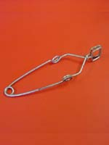 |  | A device designed especially to hold test tubes while they are hot.
 | 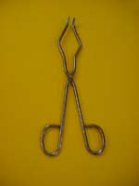 |  | A scissor-like device designed to hold hot objects. Be careful that you have a secure grip on your hot object, some tongs don't hold things as well as they should.
 | 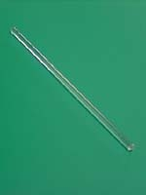 |  | A heat-proof glass rod used for stirring and mixing chemicals.
 | 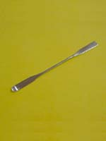 |  | A long, thin, flat piece of metal or plastic used to dish out powders and crystals.
 | 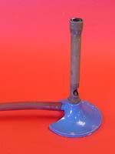 |  | A device used to heat things by burning gas in a controlled way.
 | 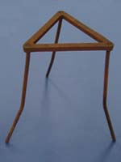 |  | A metal stand with three legs used to hold things over a bunsen burner for heating.
 | 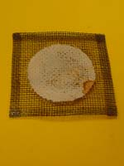 |  | A mat made of wire mesh that sits on top of a tripod and stops smaller objects from falling through the middle of the tripod.
 | 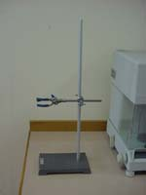 |  | A stand made of a metal base plate and a tall, thin rod, used to support equipment off the ground. A boss head (windy bolt thing) and clamp (windy fork thing) can be attached at any level to hold the equipment secure.

EQUIPMENT NAMES

RETORT STAND AND CLAMP EVAPORATING BASIN
TRIPOD TEST TUBE
BUNSEN BURNER SPATULA
STIRING ROD GAUZE MAT
CONICAL FLASK MEASURING CYLINDER
FUNNEL METAL TONGS
TEST TUBE HOLDER TEST TUBE RACK

